Chapter 3, Solution 8
5V₀

+
V₀
–

+
–
20Ω
i₁
4 Ω
6 Ω
20 Ω
i₂
i₃
v₁
–
+
60V

i₁ + i₂ + i₃ = 0 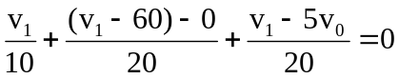
But 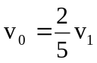 so that 2v₁ + v₁ – 60 + v₁ – 2v₁ = 0
or v₁ = 60/2 = 30 V, therefore v_{o} = 2v₁/5 = 12 V.

